Example #01: AB + BC + AC’ = Z

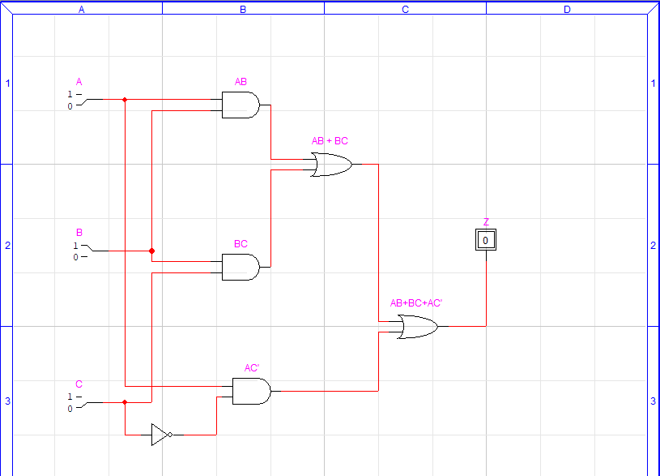

Truth Table

|  |  |  |  |  |  |  |  |  |
| --- | --- | --- | --- | --- | --- | --- | --- | --- |
| A | B | C | C’ | AB | BC | AC’ | AB+BC | Z |
| 0 | 0 | 0 | 1 | 0 | 0 | 0 | 0 | 0 |
| 0 | 0 | 1 | 0 | 0 | 0 | 0 | 0 | 0 |
| 0 | 1 | 0 | 1 | 0 | 0 | 0 | 0 | 0 |
| 0 | 1 | 1 | 0 | 0 | 1 | 0 | 1 | 1 |
| 1 | 0 | 0 | 1 | 0 | 0 | 0 | 0 | 0 |
| 1 | 0 | 1 | 0 | 0 | 0 | 1 | 0 | 1 |
| 1 | 1 | 0 | 1 | 1 | 0 | 0 | 1 | 1 |
| 1 | 1 | 1 | 0 | 1 | 1 | 1 | 1 | 1 |

Circuit #01: [Y = A + B’]

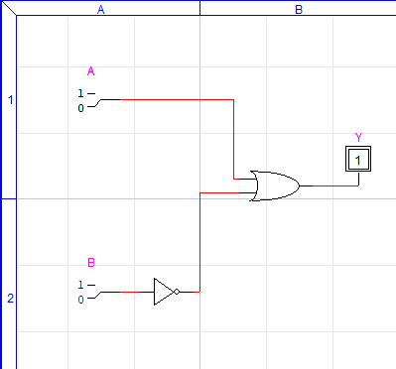

Truth Table:

|  |  |  |  |
| --- | --- | --- | --- |
| A | B | B’ | Y = A + B’ |
| 0 | 0 | 1 | 1 |
| 0 | 1 | 0 | 0 |
| 1 | 0 | 1 | 1 |
| 1 | 1 | 0 | 1 |

Circuit #02: [F = X’Y + XZ]

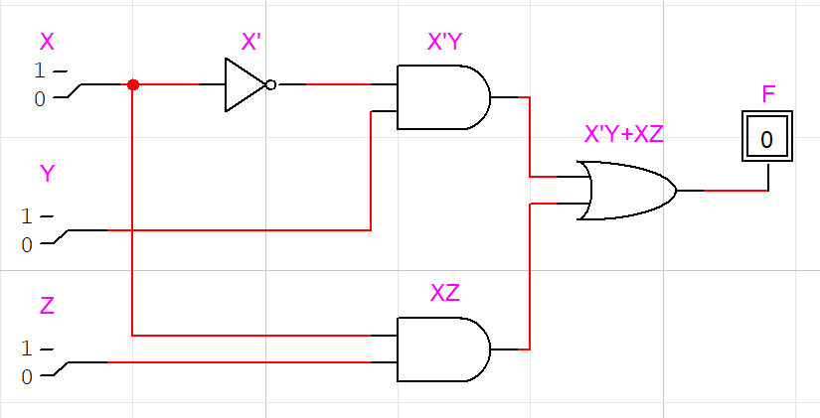

Truth Table:

|  |  |  |  |  |  |  |
| --- | --- | --- | --- | --- | --- | --- |
| X | Y | Z | X’ | X’Y | XZ | F=X’Y+XZ |
| 0 | 0 | 0 | 1 | 0 | 0 | 0 |
| 0 | 0 | 1 | 1 | 0 | 0 | 0 |
| 0 | 1 | 0 | 1 | 1 | 0 | 1 |
| 0 | 1 | 1 | 1 | 1 | 0 | 1 |
| 1 | 0 | 0 | 0 | 0 | 0 | 0 |
| 1 | 0 | 1 | 0 | 0 | 1 | 1 |
| 1 | 1 | 0 | 0 | 0 | 0 | 0 |
| 1 | 1 | 1 | 0 | 0 | 1 | 1 |

Circuit #03: C’ x {B’ + (AB+CD)’}

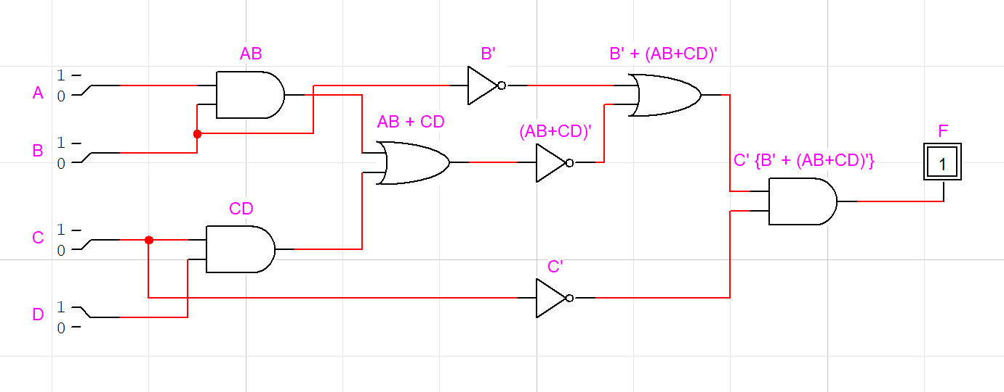

Truth Table:

|  |  |  |  |  |  |  |  |  |  |  |
| --- | --- | --- | --- | --- | --- | --- | --- | --- | --- | --- |
| A | B | C | D | B’ | C’ | AB | CD | (AB+CD)’ | {B’+(AB+CD)’} | F |
| 0 | 0 | 0 | 0 | 1 | 1 | 0 | 0 | 1 | 1 | 1 |
| 0 | 0 | 0 | 1 | 0 | 1 | 0 | 0 | 1 | 1 | 1 |
| 0 | 0 | 1 | 0 | 1 | 0 | 0 | 0 | 1 | 1 | 0 |
| 0 | 0 | 1 | 1 | 0 | 0 | 0 | 1 | 0 | 0 | 0 |
| 0 | 1 | 0 | 0 | 1 | 1 | 0 | 0 | 1 | 1 | 1 |
| 0 | 1 | 0 | 1 | 0 | 1 | 0 | 0 | 1 | 1 | 1 |
| 0 | 1 | 1 | 0 | 1 | 0 | 0 | 0 | 1 | 1 | 0 |
| 0 | 1 | 1 | 1 | 0 | 0 | 0 | 1 | 0 | 0 | 0 |
| 1 | 0 | 0 | 0 | 1 | 1 | 0 | 0 | 1 | 1 | 1 |
| 1 | 0 | 0 | 1 | 1 | 1 | 0 | 0 | 1 | 1 | 1 |
| 1 | 0 | 1 | 0 | 1 | 0 | 0 | 1 | 1 | 1 | 0 |
| 1 | 0 | 1 | 1 | 1 | 0 | 0 | 0 | 0 | 0 | 0 |
| 1 | 1 | 0 | 0 | 0 | 1 | 1 | 0 | 0 | 1 | 0 |
| 1 | 1 | 0 | 1 | 0 | 1 | 1 | 0 | 0 | 0 | 0 |
| 1 | 1 | 1 | 0 | 0 | 0 | 1 | 0 | 0 | 1 | 0 |
| 1 | 1 | 1 | 1 | 0 | 0 | 1 | 1 | 0 | 0 | 0 |